[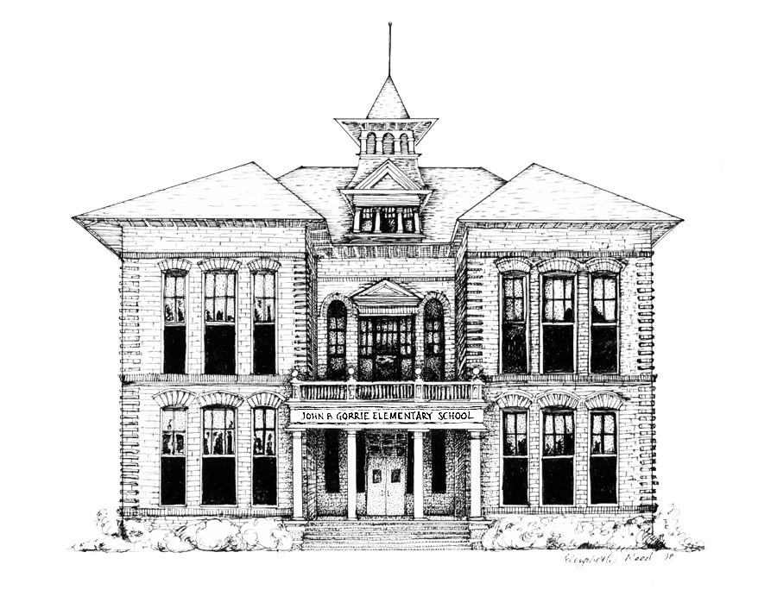](http://www.sdhc.k12.fl.us/~gorrie.elementary/)

# Principal

Marjorie Sandler

**Assistant Principal for Elementary Instruction**

Alesha Looper

**Hillsborough County Public Schools**

**John B. Gorrie Elementary School**

**Gorrie Elementary Lunchroom Management Plan 2022-23**

Good lunchroom manners should reflect expectations of dining at home and in social/restaurant settings.  Our staff is implementing a plan that will ensure a positive eating environment for all students.

Our lunchroom rules are as follows:

1. Enter and exit the cafeteria quietly
2. Show your respect to everyone in the lunchroom
3. Stay in your assigned seat
4. Talk softly to those at your table
5. Raise your hand for help
6. Eat your own food
7. Keep personal items at home
8. Clean up your area and wait for dismissal

Our school can be exemplary in every way!  Our lunchroom deserves the same commitment to excellence we have in all of our classrooms and programs.  Please work with us as we make the lunchtime an enjoyable, relaxing half-hour for you youngsters.

**\*\*\* PLEASE NOTE\*\*\***

**Due to an increased student enrollment, we do not have room in the cafeteria for visitors eating lunch with students.  Only food served by Student Nutrition Services or lunch boxes from home will be permitted in the cafeteria.  No Fast Food will be permitted.  In order to keep our students safe, students are required to eat in the lunchroom under the supervision of school board personnel.**

I have read and discussed Gorrie’s Lunchroom rules with my child.

Child’s Name_________________________________________

Teacher_____________________________________________

Signature of Parent/Guardian____________________________